EGC446 VLSI Design Lab

How to download and setup the VLSI layout software into the Laptop

The free VLSI software that we use is Electric VLSI from Oracle, Inc. The site CMOSedu.com is a complete VLSI design course run by Prof. Jacob Baker. All details of Electric VLSI and required tutorials are available from CMOSedu.com. If you can watch the Electric VLSI tutorials in this site (https://cmosedu.com/videos/electric/electric_videos.htm), Tutorial 1 video (first 15 minutes of this video), it will take you through the whole installation process in a step-by-step manner. Electric VLSI software is used to make transistor schematics and layout. The program includes design rule checks, Electric rule checks and layout and schematics comparison.

First create a new directory in your computer (eg. Electric) and save all the following under that directory.

- Installation of Java latest version
To run Electric on your computer, you need Java17 or later versions. To download Java, go to: https://oracle.com/java/technologies/downloads/

Select the latest version JDK25 and click on Windows (version), and select x64 installer:
https://download.oracle.com/java/25/latest/jdk-25_windows-x64_bin.exe (sha256)
Double click on the executable file saved under downloads on your computer, and give all permissions, which will install Java on your computer.

- Installation of ELECTRIC VLSI: First go to: CMOSedu.com. Then click on the tab: Electric VLSI. All the information needed is given there. This site allows you to download “electric-9.07.jar”, which is an older version. A new version is available, which is version 9.08. The new version is available from: staticfreesoft.com. To download this new version, first Click on the Download tab and select code. Now click on
“GET THE GNU ELECTRIC BINARY RELEASE, version 9.08”

You may use the instructions given under CMOSedu.com.

The functionality of the designed circuits (both schematics and layout) is verified by simulation. The simulation program is not included with Electric VLSI. A separate program LTspice (Linear Technology spice) is used for simulation. Hence, we need to download and set up LTspice also.

- Installation of LTspice
LTspice can be downloaded from Analog Devices. To do this,
Google: “LTspice download” and click on:
LTspice Simulation Software – Download LTspice

Now click:
Download for Windows 10 64-bit and forward Version 26.0.1
Download it, extract it and then set it up.
We also need transistor spice model files for performing simulation.
- Transistor model files (spice models)
An older 0.5um transistor model file (C5_models.txt) is available from CMOSedu.com. But we are going to use 180nm (0.18um) transistor model files for our lab. The one which we use is tsmc018, which is from TSMC (Taiwanese Semiconductor Manufacturing Consortium). TSMC is a very popular IC foundry for manufacturing IC chips.
The technology files needed for TSMC 180nm process are (3 files):
- Library file: tsmc018.lib
- Symbol files: cmosn.asy and cmosp.asy
You need to download the above three files and set it up with LTspice. To download them go to:
https://sanjayvidhyadharan.in/Downloads
and click on “tsmc_180_nm”, which gives you access to “tsmc_180-nm.zip” file. Download the Zip file and extract it in your folder. All three files are available in the Zip folder.

Alternatively, an older version of LTspice (LTspice XVii) is also available through the above site (LT_SPICE_Installation_Files.rar). You can download and extract it and then install it. This is also ok for us instead of the latest LTspice version 26.0.1.

Adding TSMC180nm Technology files with LTspice

- Open LTspice
- Open a New Schematic (File – New Schematic)
- Click on ‘Component’ tab (looks like an IC chip) on the schematic window
- Note the ‘Top Directory’ path (C:\users\...\Documents\LTspiceXVii\lib\sym)
- In the above folder, paste the symbols cmosn.asy and cmosp.asy
- Go back to the lib directory and select ‘sub’ folder
- Paste ‘tsmc018.lib’ in the sub folder
- Now click on spice directive (.op which is the last tab for LTspice XVII or .t for LTspice 26)
- In the new window, select ‘Spice Directive’ and Type ‘.INCLUDE tsmc018.lib’

A video tutorial to download and set up tsmc files with LTspice is available under:

https://www.youtube.com/watch?v=49naoDY34nU

Increasing the Memory limit of the Java Virtual Machine (JVM) for larger designs
- To increase Electric’s available memory (default is 64 MB) go to File -> Preferences -> General -> General and increase the maximum memory size as seen below. Note that if you are using the waveform viewer in Electric and not increasing the maximum memory then it will be easy to run out of memory when reading a SPICE raw file resulting in an “Exception Caught!”
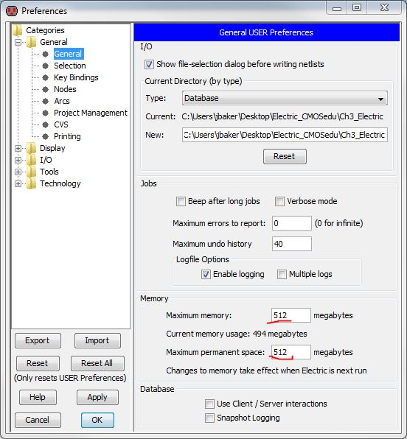
Adjustments needed so that LTSPICE works with Electric
- Start Electric and go to File -> Preferences (see image below). The Run Program path is either:
- C:\PROGRA~1\LTC\LTspiceIV\scad3.exe or
C:\PROGRA~2\LTC\LTspiceIV\scad3.exe or, if using LTspice XVII,
C:\PROGRA~1\LTC\LTspiceXVII\XVIIx64.exe
C:\PROGRA~2\LTC\LTspiceXVII\XVIIx64.exe
where, using the 8.3 filename, C:\PROGRA~1\ is the same as C:\Program Files\ and C:\PROGRA~2\ is the same as C:\Program Files (x86)\.
- Note that while the Run Program field is not case sensitive the “with args:” field is case sensitive (so use the uppercase names as seen)
Copy into the “with args:” field: -i ${FILENAME} -r ${FILENAME_NO_EXT}.raw -o ${FILENAME_NO_EXT}.out
- Cross-probing between layout or schematic using Electric’s Probe window (instead of LTspice’s probe), can be done with these setups if the –i (interactive) is changed to –b (batch)
Ensure that in LTspice, Tools -> Control Panel -> Operation, raw files (simulation results) are not automatically deleted when LTspice is closed else you won’t see the results!!!
If you get an Exception Caught!!! when Electric loads simulation data it likely means that you have run out of memory. See number 15 here for how to increase the memory allocated to the JVM

